Chapter 4, Solution 52.

For the transistor model in Fig. 4.118, obtain the Thevenin equivalent at terminals a-b.

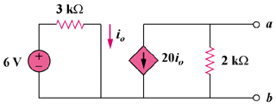
12 V

Figure 4.118
For Prob. 4.52.

Solution

Step 1. To find the Thevenin equivalent for this circuit we need to find v_{oc} and i_{sc}.
Then V_{Thev} = v_{oc} and R_{eq} = v_{oc}/i_{sc}.
+
20I_{o}
v_{oc}
2 kΩ

b

a

I_{o}
12V

+
−
3 kΩ
–
i_{sc}

For v_{oc}, I_{o} = (12–0)/3k = 4 mA and 20I_{o} + (v_{oc}–0)/2k = 0.

For i_{sc}, i_{sc} = –20I_{o}.

Step 2. v_{oc} = –2k(20I_{o}) = –40x4 = –160 volts = V_{Thev}

i_{sc} = –20x4x10^{–3} = –80 mA or

R_{eq} = –160/(80x10^{–3}) = 2 kΩ.

